DATAPUMP JOB PAUSE & KILL PROCESS
How to take schema level backup with job
expdp system/oracle directory=exp_dir dumpfile=hr.dmp logfile=hr.log schemas=hr job_name=exp_hr
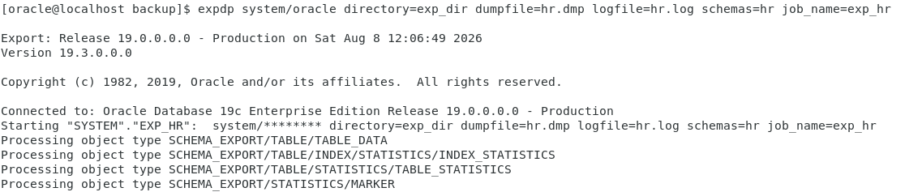
I’ve to check the job _status in another terminal.
SELECT OWNER_NAME,JOB_NAME,OPERATION,JOB_MODE,STATE FROM dba_datapump_jobs;
After that, I pause the job.
Ctrl+c
Export> stop_job = immediate (yes).
Now, check the job is stopped or not, check the below command.
SELECT OWNER_NAME,JOB_NAME,OPERATION,JOB_MODE,STATE FROM dba_datapump_jobs;
After some times, I’ve to run the existing job.
expdp system/oracle attach=JOB_NAME (exp_hr)
EXPORT> continue_client
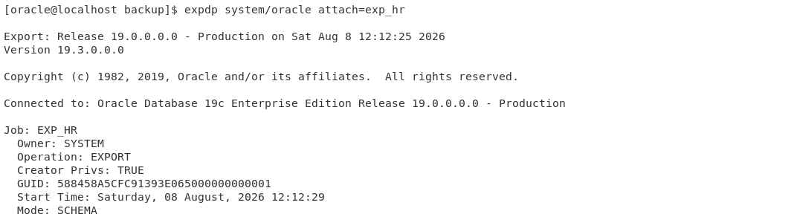
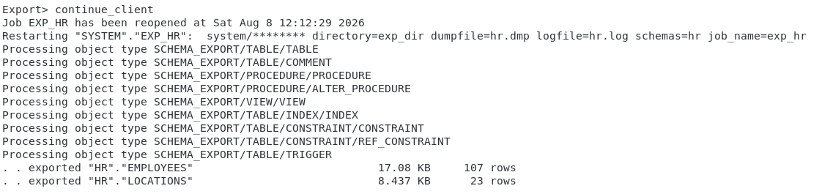

- KILL JOB =>
ctrcl+c
export> kill_job (yes).

